Challenge: Draw a Monkey

**Step 1** Draw three circles to make the ears and the face.

* In Macintosh HD:Users:ji-sunham:Desktop:Screen Shot 2015-02-03 at 5.02.37 PM.png mode, start with these three commands to make one ear:
  + **rt 90**
  + **bk 50**
  + **dot brown, 60**
* Add the following for the second ear:
  + **fd 100**
  + **dot brown, 60**
* Now draw a large dot for the face!
  + **bk 50**
  + **dot orange, 100**
* Press  to draw the monkey’s face and ears.

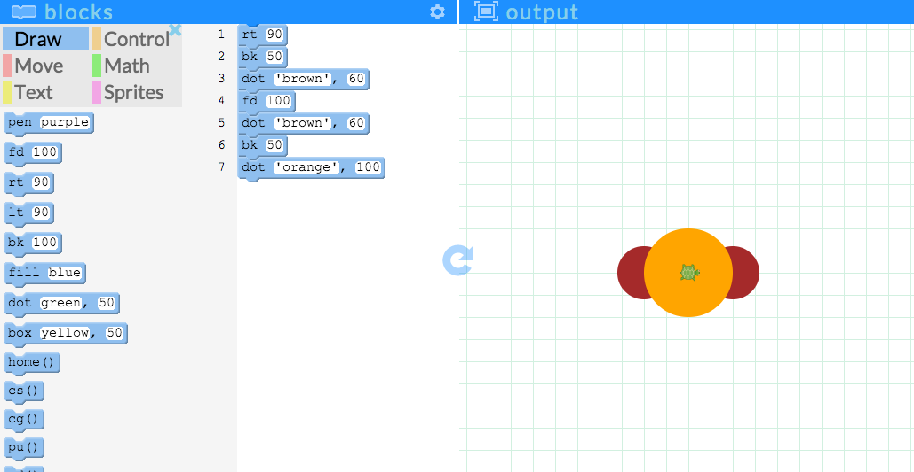

**Step 2** Draw two small dots for the monkey’s eyes.

* Drag the following blocks to draw the eyes:
  + **bk 30**
  + **dot black, 10**
  + **fd 60**
  + **dot black, 10**

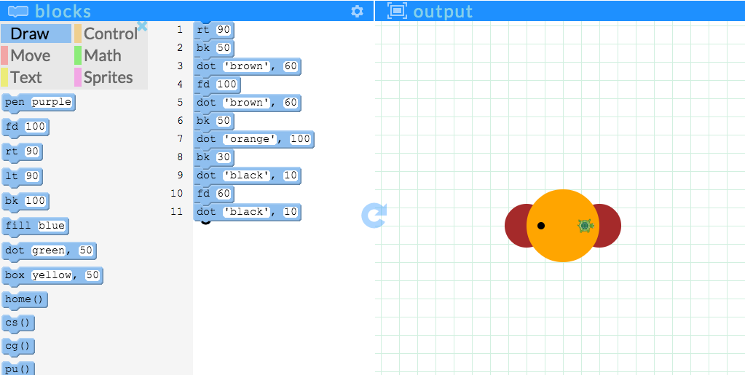

**Step 3 (Optional)** Give the monkey a smile!

* If you switch into :general:Screen Shot 2015-02-05 at 10.02.46 PM.png mode, you can type a note to yourself by using **#**. This allows you to make notes without interfering with your program!
  + **# optional smile**
* After your **#** note, you can type or drag your commands to draw a smile on the monkey:
  + **rt 90**
  + **fd 100**
  + **pen red**
  + **rt 180, 30**
* Press  to check your program.

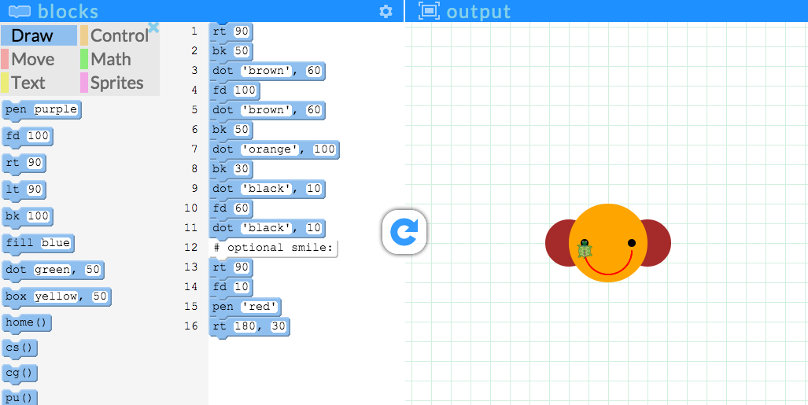

* Tip: To hide the turtle, type in **ht()** in :general:Screen Shot 2015-02-05 at 10.02.46 PM.png mode!
* This is what your program might look like in code mode:

